

PROJECT 2020

1. *Participants:*

Raya Lilova – [RSLilova18@codingburgas.bg](mailto:RSLilova18@codingburgas.bg)

Stivan Lilov – [SSLilov18@codingburgas.bg](mailto:SSLilov18@codingburgas.bg)

Boyan Binev – [BGBinev18@codingburgas.bg](mailto:BGBinev18@codingburgas.bg)

Radoslav Ivanov – [RMIvanov18@codingburgas.bg](mailto:RMIvanov18@codingburgas.bg)

Kaloyan Dimov– [KDDimov18@codingburgas.bg](mailto:KDDimov18@codingburgas.bg)

1. *Content:*

Level1- Participants

Level2-Content

Level3-Purpose for our project

Level4-Diagram of the menu

Level5- Main functions from the program and their purpose

1. *Purpose of our project*

The purpose of our project is to fill in the user's time as revise his knowledge in English, guesses and find the words and mainly have fun!

1. *Diagram of the menu:*

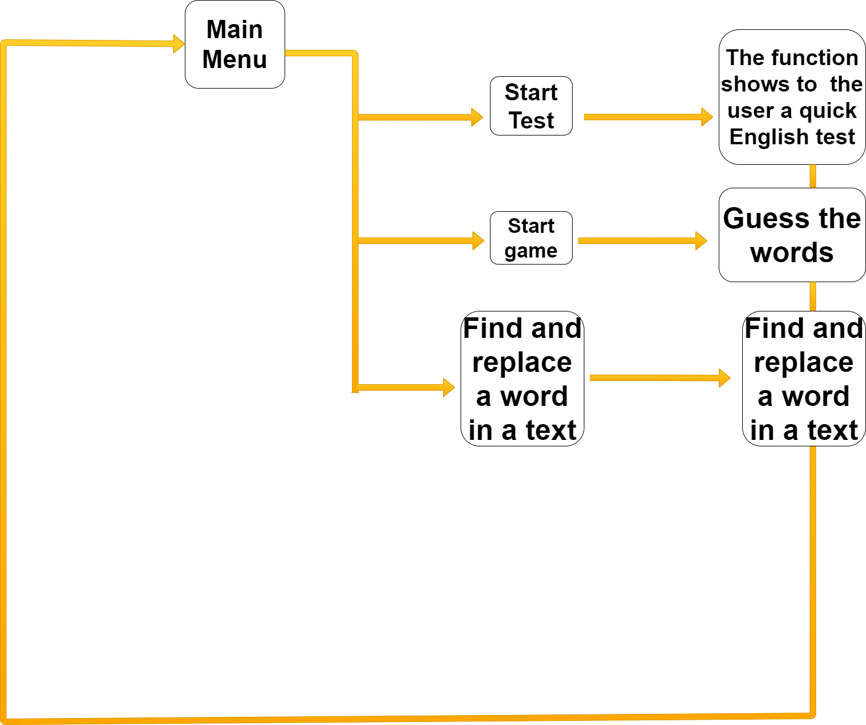

1. *Main functions from the program and their purpose*

|  |  |
| --- | --- |
| **Name of the function:** | **The main idea of the function:** |
| level(); | For choosing an option for the game(animals,professions) |
| Game(); | The main function for the game |
| find(); | Function for the 3rd option- find and replace a word in a text |
| Questions(); | Function for the questions of the 1st option in our Menu(Start Test) |
| Menu(); | Function for the Main Menu of the programm |